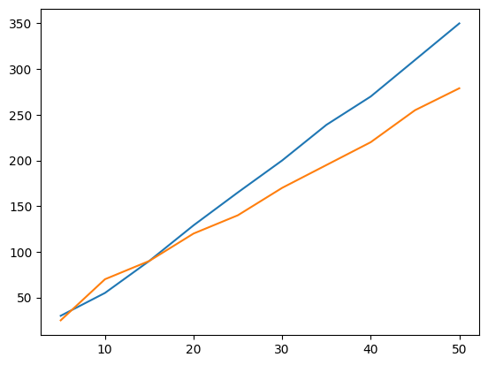
/tmp/ipykernel_3969/506286342.py:11: UserWarning: No artists with labels found to put in legend. Note that artists whose label start with an underscore are ignored when legend() is called with no argument.
cricket.legend()
<matplotlib.legend.Legend at 0x7b01e7761bd0>
